**Nested routing**

**Title: Set up nested routes using React Router for a multi-level menu.**

**1. Task Description:**

Create a feature demonstrating nested routing in React.

* The app contains a **Dashboard** with links to a **Profile** page.
* The **Profile** page has sub-routes for **ProfileView** and **ProfileSettings**, using React Router's nested routing feature.
* Each sub-route dynamically displays relevant content.
* Added Tailwind CSS for modern design and responsiveness.

#### ****2. Task Output Screenshot:****

**Screenshots:**

1. **Dashboard with Navigation Links:**

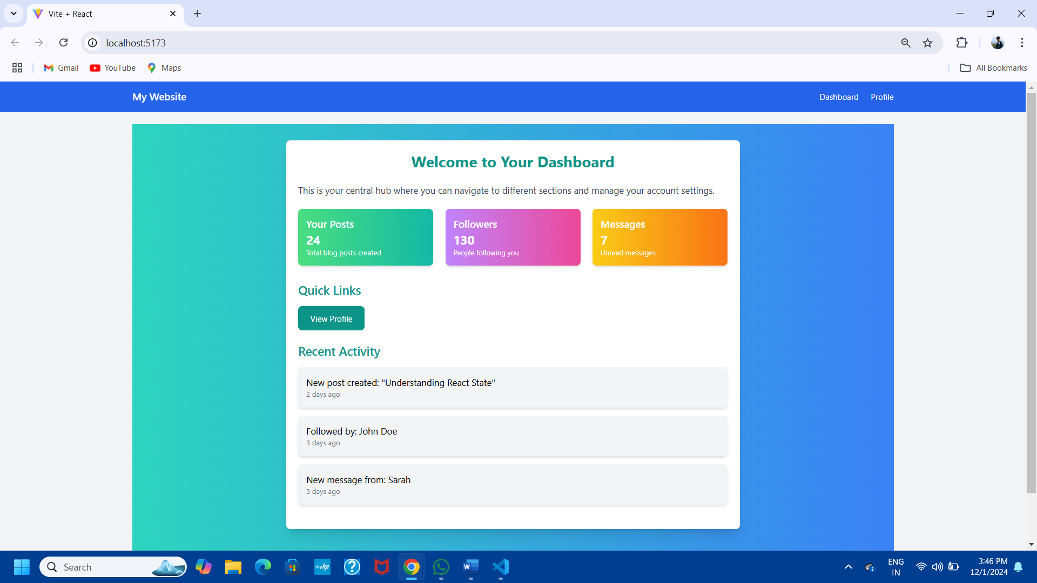

1. **Profile Page with Nested Routes:**

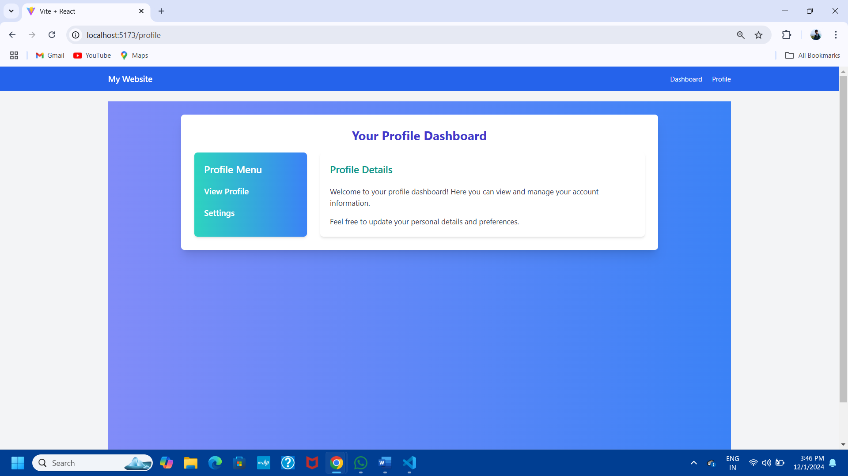

1. 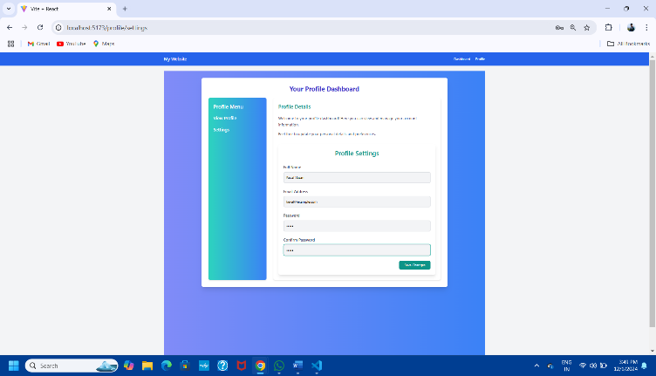**ProfileView and ProfileSettings Pages:**

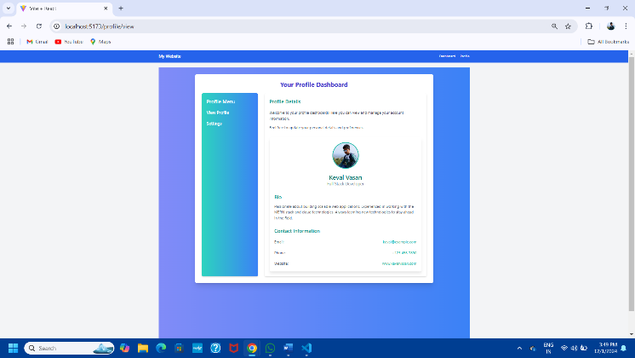

**3. Widget/Algorithm Used in Task:**

* **React Router DOM for Nested Routing:**
  + **Parent Route (Dashboard):** Contains navigation links to the Profile page.
  + **Child Routes (ProfileView, ProfileSettings):** Nested under the Profile route for specific content rendering.
* **Dynamic Routing Logic:**
  + Used <Route> components with path and element attributes to define parent and child routes.
  + Leveraged Outlet for rendering nested child routes dynamically within the Profile page.
* **HTML and CSS Elements Used:**
  + **Links:** Used <Link> components for smooth navigation between routes.
  + **Tailwind CSS Classes:**
    - Designed a **modern, responsive layout** with gradients, shadows, and hover effects.
    - Ensured full responsiveness using flex, grid, and gap utilities.
* **Dynamic State Management:**
  + React’s hooks (useParams) used to fetch dynamic route parameters for displaying content.